Chad Galloway

CST-250 Programming in C# II

Grand Canyon University

Nov. 2, 2025

Activity 2

Files

<https://github.com/CGalloway3/CST-250-Projects/tree/master/Activity%202>

Video

[Video Link]

FLOW CHART



Figure X: Flow chart of XXXXXXX

"Lorem ipsum dolor sit amet, consectetur adipiscing elit, sed do eiusmod tempor incididunt ut labore et dolore magna aliqua. Ut enim ad minim veniam, quis nostrud exercitation ullamco laboris nisi ut aliquip ex ea commodo consequat. Duis aute irure dolor in reprehenderit in voluptate velit esse cillum dolore eu fugiat nulla pariatur. Excepteur sint occaecat cupidatat non proident, sunt in culpa qui officia deserunt mollit anim id est laborum."

UML Class Diagram



Figure X: UML Class Diagram

Lorem ipsum dolor sit amet, consectetur adipiscing elit, sed do eiusmod tempor incididunt ut labore et dolore magna aliqua. Ut enim ad minim veniam, quis nostrud exercitation ullamco laboris nisi ut aliquip ex ea commodo consequat. Duis aute irure dolor in reprehenderit in voluptate velit esse cillum dolore eu fugiat nulla pariatur. Excepteur sint occaecat cupidatat non proident, sunt in culpa qui officia deserunt mollit anim id est laborum.

**Part 1**

Screen Shots

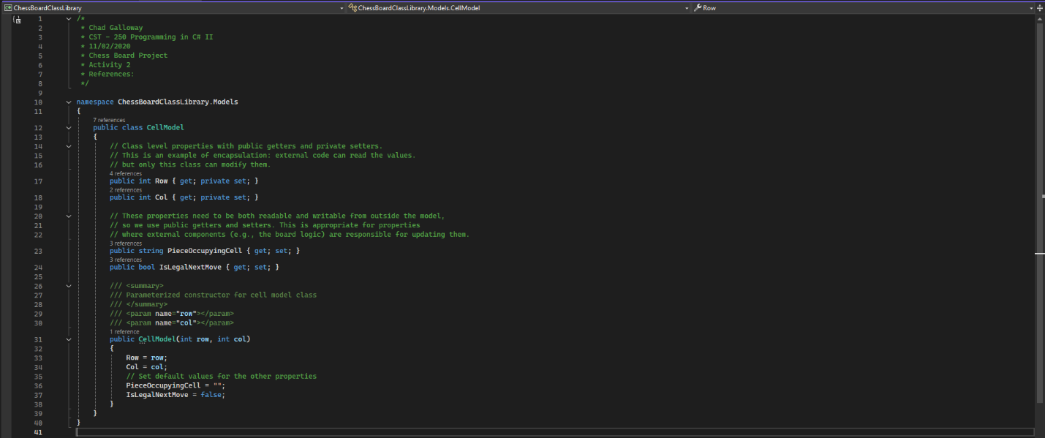

Figure 1: CellModel citations and constructor

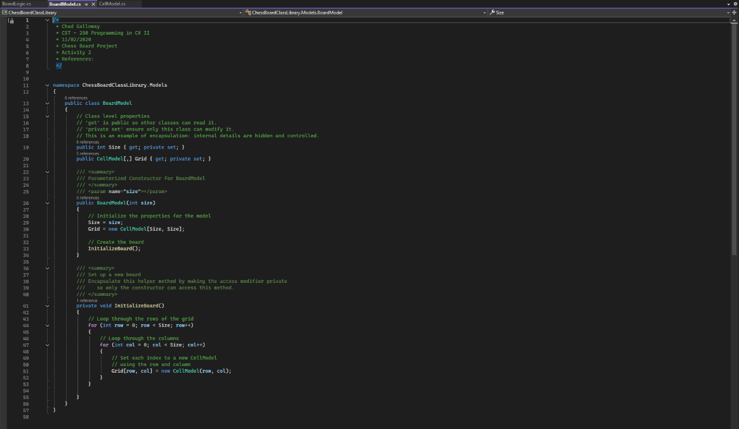

Figure 2: BoardModel citations and constructor

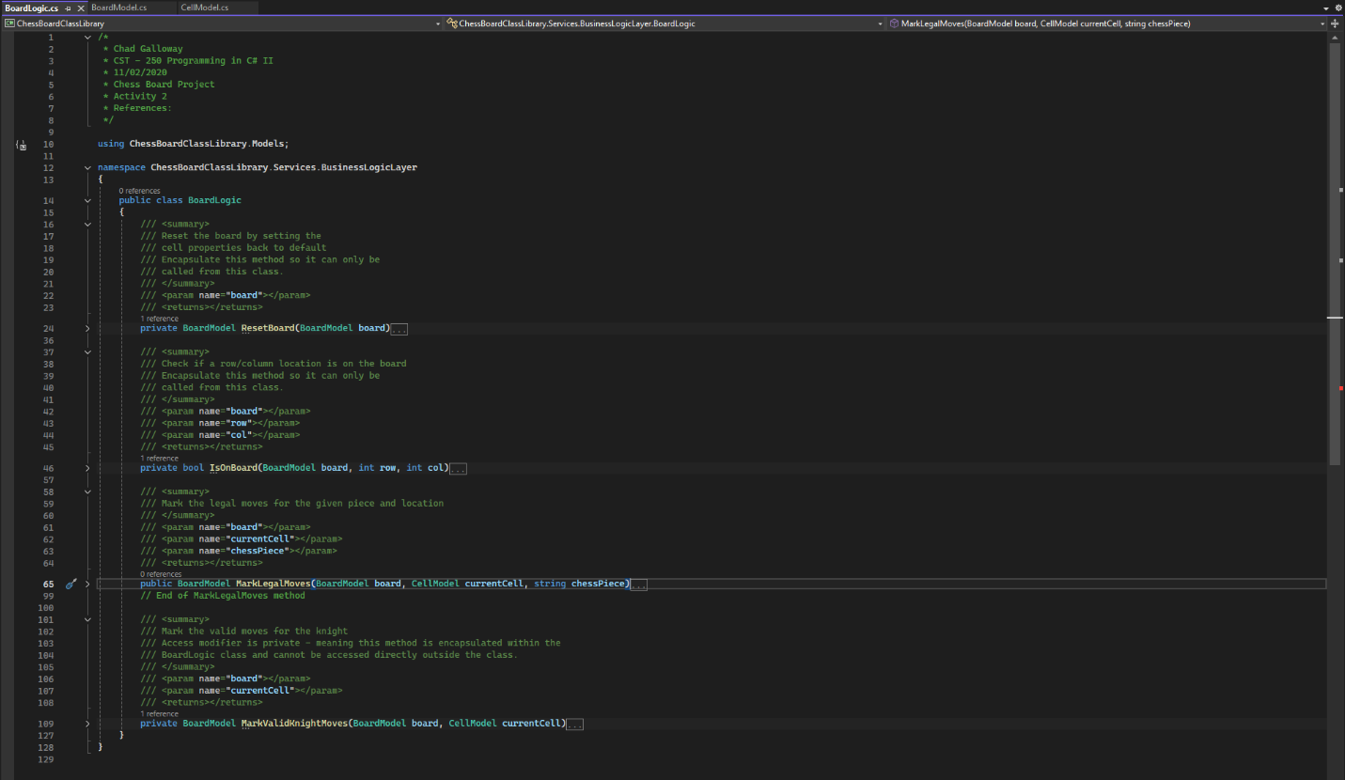

Figure 3: BoardLogic and collapsed methods with expanded summary

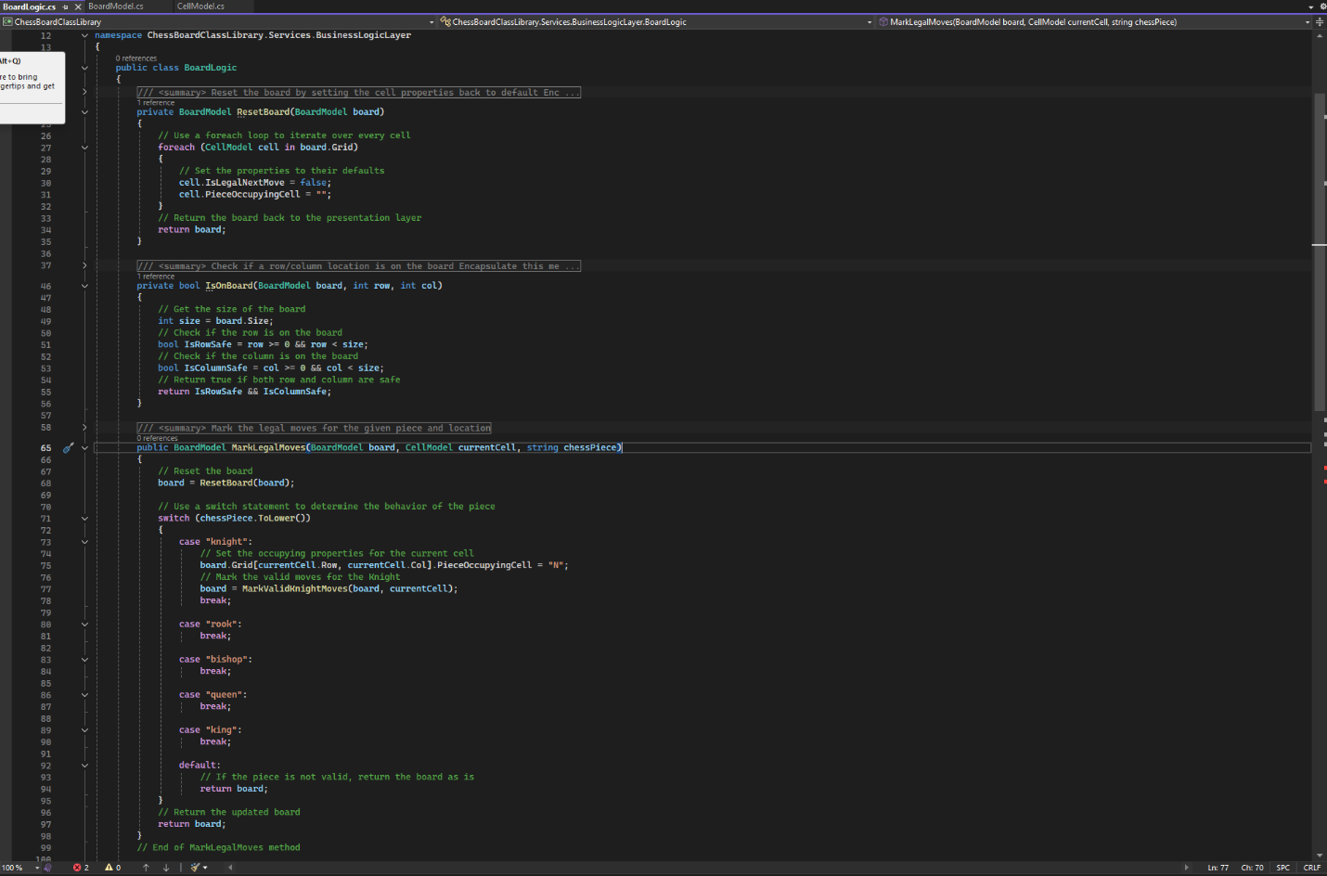

Figure 4: BoardLogic: ResetBoard(), IsOnBoard(), and MarkLegalMoves() with collapsed summaries

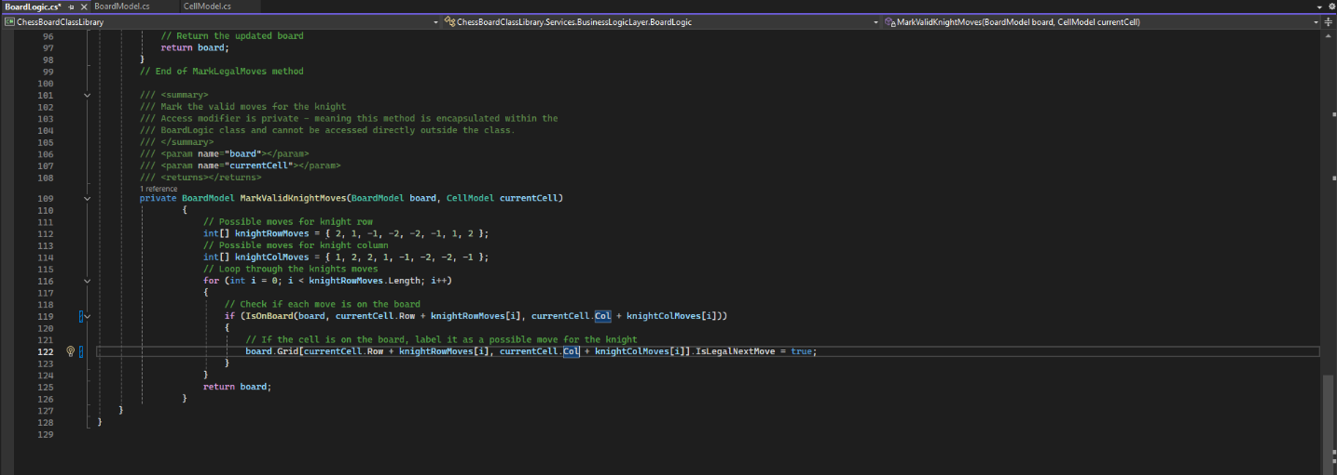

Figure 5: BoardLogic.MarkValidKnightMoves()

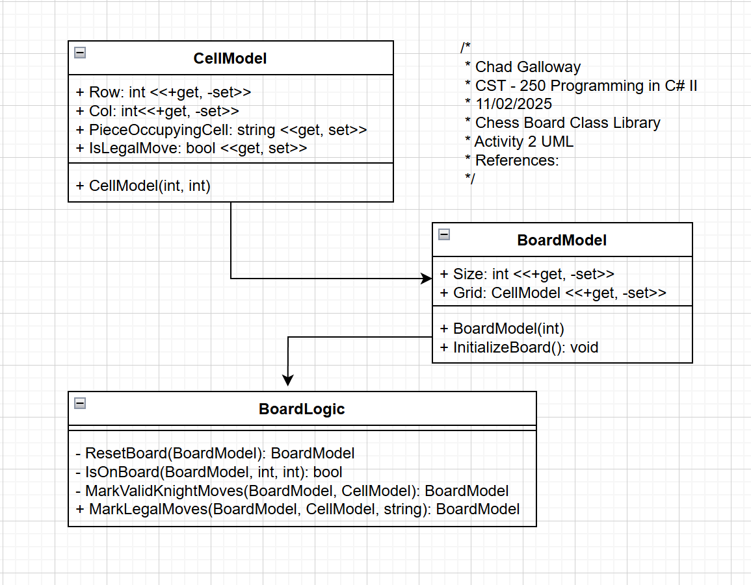

Figure 6: Screenshot of UML for CellModel, BoardModel, and BoardLogic

Challenges

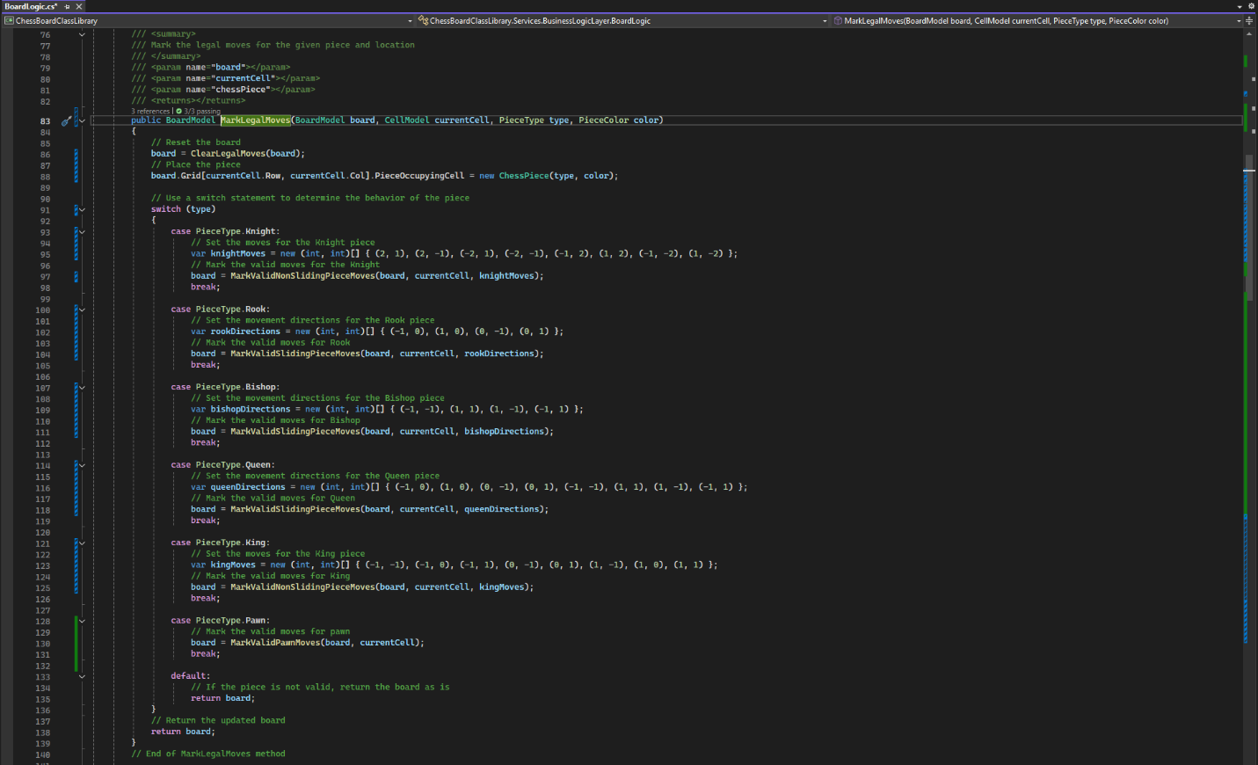

Figure 7: Updated and completed BoardLogic.MarkLegalMoves() method. Changed the string parameter for piece to type and color enums I created. Moved piece creation out of the cases and into the main body using a ChessPieice class I ceated.

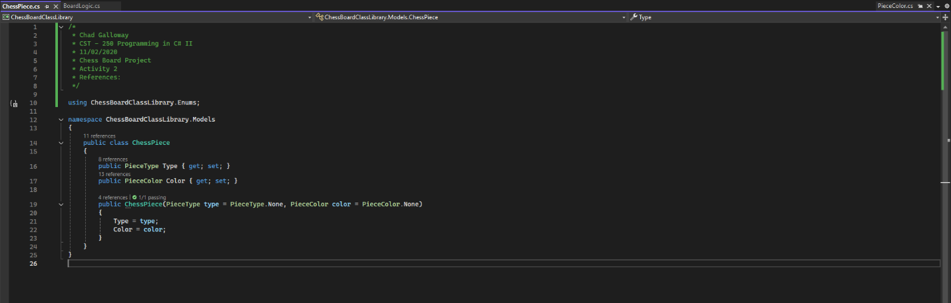

Figure 8: ChessPiece class. Contains piece type and piece color. Currently the piece doesn’t do anything (no methods). In the future it might have some movement methods added in we will see.

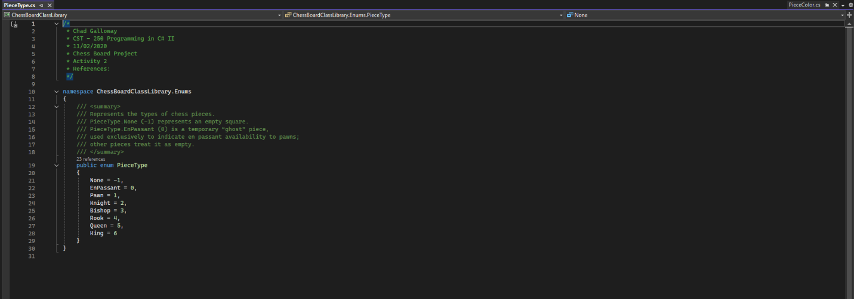

Figure 9: PieceType enum to hold all the different piece types including none and en passant a “ghost” piece type only visible in code to pawns for preforming the en passant move.

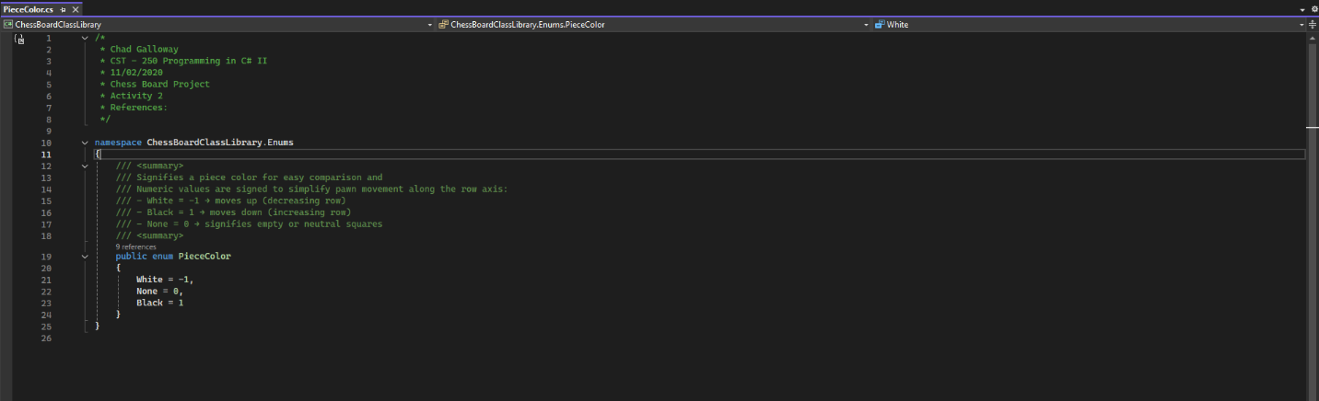

Figure 10: PieceColor emun to hold the colors of pieces. Used to determine if a legal move of taking an enemy piece is available and it is also a directional indicator of the movement directions of the two colored pieces for pawns. Black pawns move down the board +1, and white pawns move up the board -1.

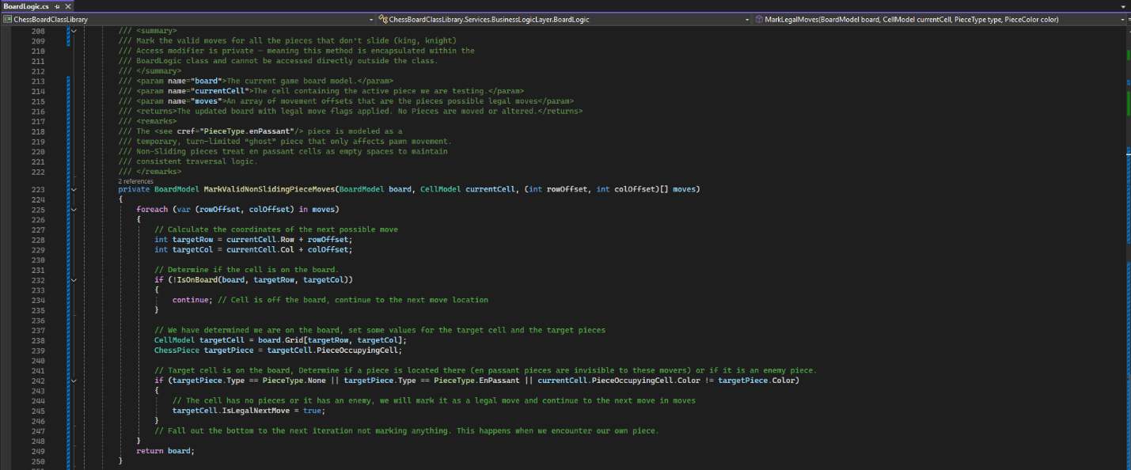

Figure 11: BoardLogic.MarkValidKnightMoves() was removed and combined with the king logic into a method for all non-sliding pieces MarkValidNonSlidingPieceMoves(). It handles knights and kings.

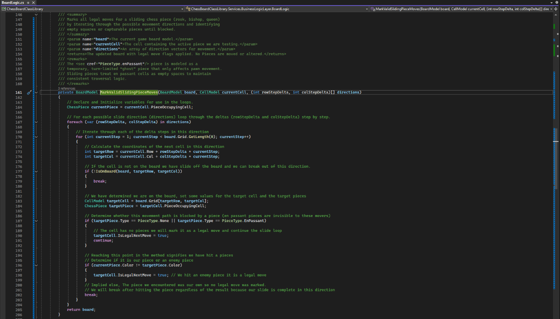

Figure 12: BoardLogic.MarkValidSlidingPieceMoves() was added to handle pieces that slide (i.e. rook, bishop, and queen)

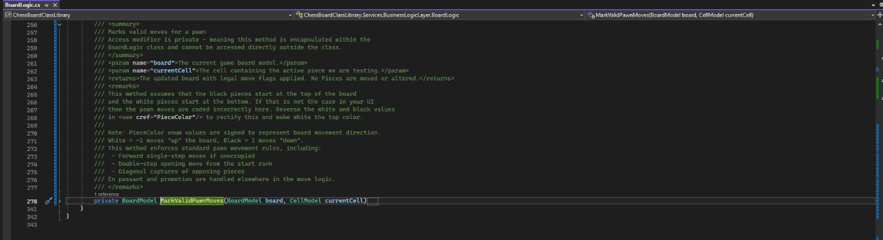

Figure 13: Summary for MarkValidPawnMoves()

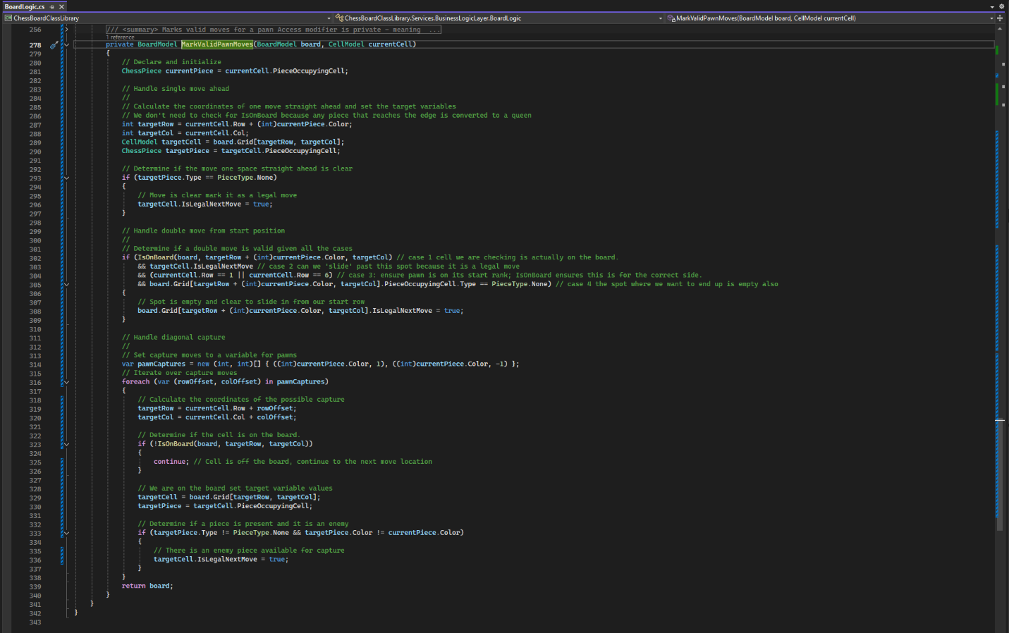

Figure 14: BoardLogic.MarkValidPawnMoves() marks all the movement cases for pawns. Promotions for reaching the last rank and en passant will be handled in the actual move logic. Here we are just highlighting what might be a legal move.

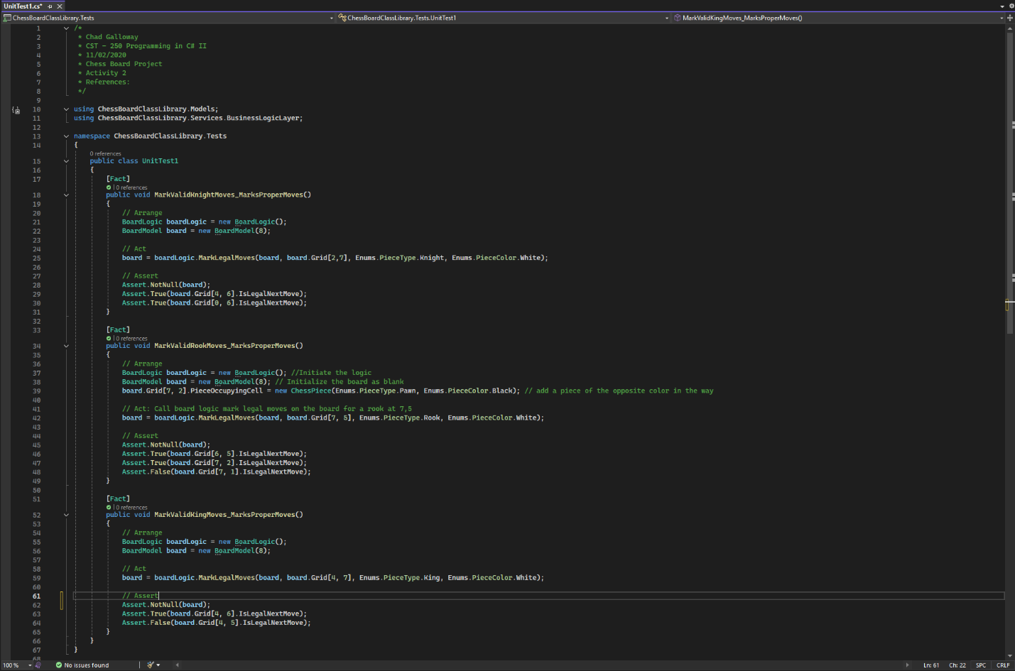

Figure 15: Several unit tests were created for the project to make coding the different MarkValid methods easier.

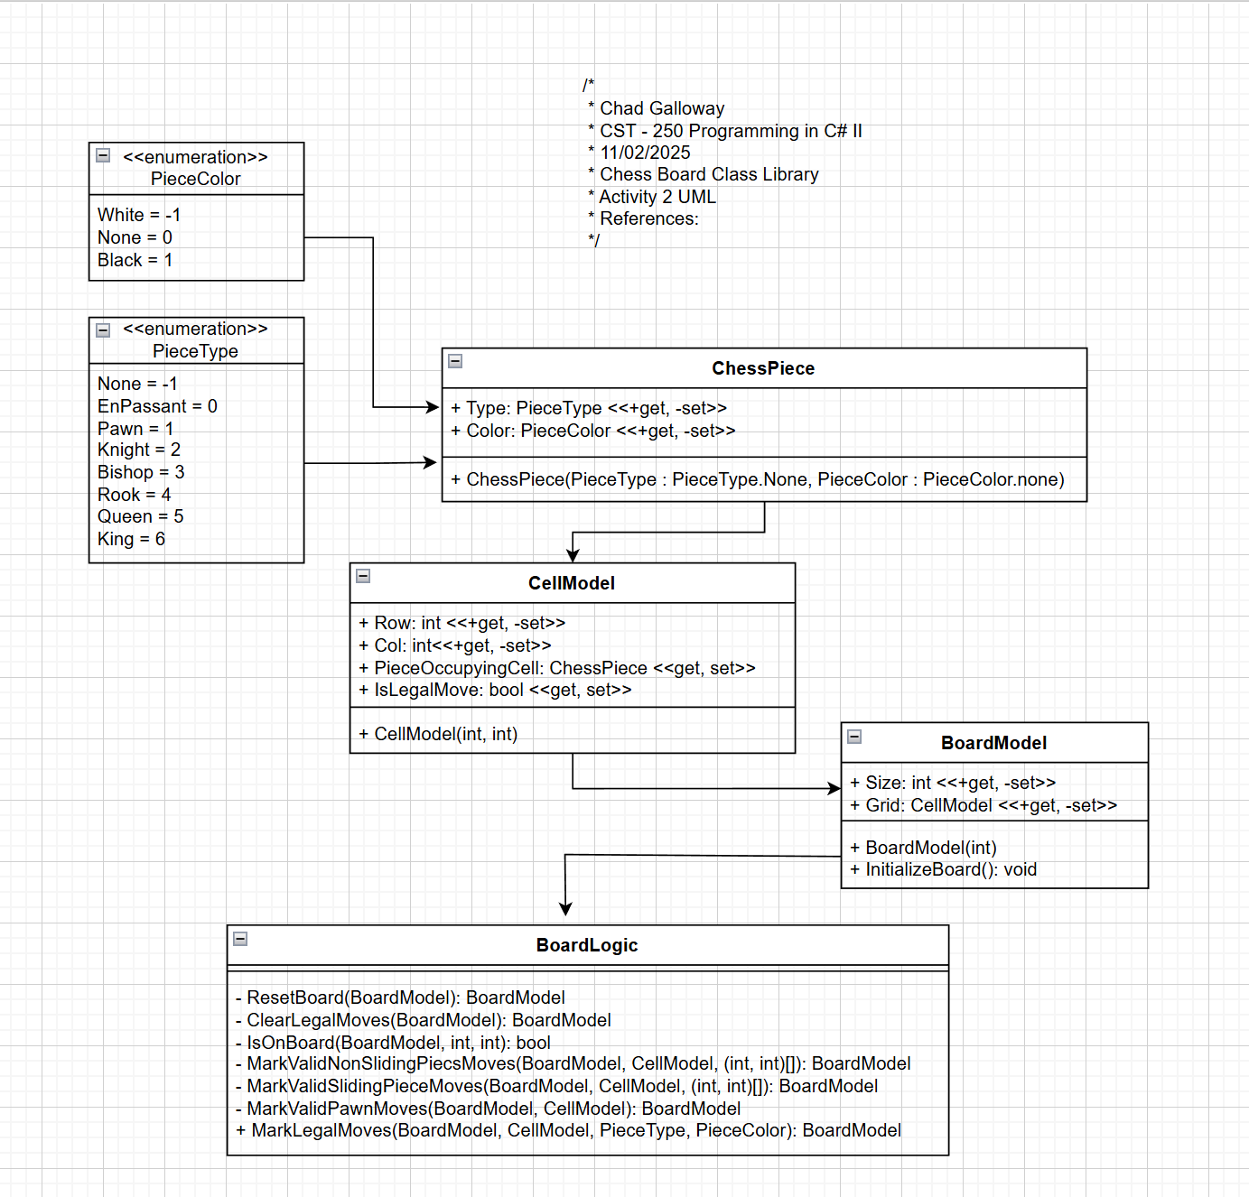

Figure 16: Projects UML so far.

Part 2



Figure X: Part 2 App Running

Lorem ipsum dolor sit amet, consectetur adipiscing elit, sed do eiusmod tempor incididunt ut labore et dolore magna aliqua. Ut enim ad minim veniam, quis nostrud exercitation ullamco laboris nisi ut aliquip ex ea commodo consequat. Duis aute irure dolor in reprehenderit in voluptate velit esse cillum dolore eu fugiat nulla pariatur. Excepteur sint occaecat cupidatat non proident, sunt in culpa qui officia deserunt mollit anim id est laborum.



Figure X: Screenshot of successful output

Lorem ipsum dolor sit amet, consectetur adipiscing elit, sed do eiusmod tempor incididunt ut labore et dolore magna aliqua. Ut enim ad minim veniam, quis nostrud exercitation ullamco laboris nisi ut aliquip ex ea commodo consequat. Duis aute irure dolor in reprehenderit in voluptate velit esse cillum dolore eu fugiat nulla pariatur. Excepteur sint occaecat cupidatat non proident, sunt in culpa qui officia deserunt mollit anim id est laborum.



Figure X: Screenshot of Error Handling

Lorem ipsum dolor sit amet, consectetur adipiscing elit, sed do eiusmod tempor incididunt ut labore et dolore magna aliqua. Ut enim ad minim veniam, quis nostrud exercitation ullamco laboris nisi ut aliquip ex ea commodo consequat. Duis aute irure dolor in reprehenderit in voluptate velit esse cillum dolore eu fugiat nulla pariatur. Excepteur sint occaecat cupidatat non proident, sunt in culpa qui officia deserunt mollit anim id est laborum.

ADD ON

**Follow up Questions**

1. What was challenging?
2. What did you learn?
3. How would you improve on the project?
4. How can you use what you learned on the job?